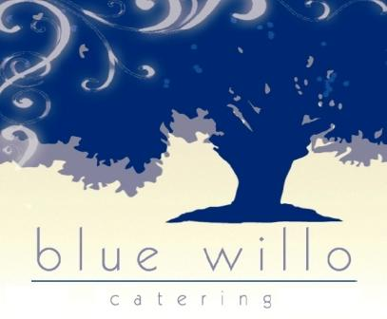

"This institution is an equal opportunity provider."

September Lunch 2022 Step up

Menu subject to change due to supply chain issues

Choice of milk

1% white or skim

|  |  |  |  |  |
| --- | --- | --- | --- | --- |
| **Monday** | **Tuesday** | ***Wednesday*** | **Thursday** | **Friday** |
|  |  |  | 1  Chicken and Cheese Enchilada  Salsa  Tropical Bean Salad  Fruit Bar  Tortilla chips  Sour Cream | 2  French Bread Pepperoni Pizza  Garden Salad |
| 5 | 6  Hot Dog on WG Bun  Baby Carrots  Fruit Bar  Ranch Dressing  Ketchup Packet  Mustard Packet | 7  WG Macaroni & Cheese  Cut Green Beans  Unsweetened Applesauce Cup  Almond Milk | 8  Chicken Crispitos  Refried Beans  Pineapple Salsa  100% Fruit Juice  Sour Cream  Avocado Salsa | 9  French Bread Pepperoni Pizza  Garden Salad  Fruit Bar |
| 12  Popcorn Chicken  Mashed Potatoes  Mixed Fruit | 13  Mini Corn Dogs  Whole Kernal Corn  Assorted Fresh Melon Bowl | 14  Bang Bang Chicken  Cut Green Beans  Fresh Oranges  Brown Rice | 15  Macaroni with Meat Sauce  Refried Beans  Salsa  Fruit Bar  Brown Rice  Sour Cream | 16  Cheese Galaxy Pizza  Garden Salad  Carrot Sticks |
| 19  Chicken Tenders  Seasoned Potato Wedge  Mixed Fruit | 20  Cheeseburger  Corn Cobbette  Carrot Sticks  Assorted Fresh Melon Bowl  Mustard Packet | 21  Wokin' Orange Chicken  Asian Veggies  Cauliflower Florets  Fresh Oranges  Brown Rice | 22  Walking Taco  Pinto Beans  Pineapple Tidbits | 23  Cheese Galaxy Pizza  Garden Salad |
| 26 | 27 | 28 | 29 | 30 |