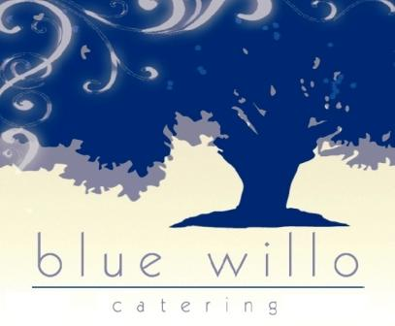

Step up September Breakfast 2022

Choice of milk

1% white or skim

"This institution is an equal opportunity provider."

|  |  |  |  |  |
| --- | --- | --- | --- | --- |
| **Monday** | **Tuesday** | ***Wednesday*** | **Thursday** | **Friday** |
|  |  |  | 1  Cinnamon Roll  Fruit Bar  100% Fruit Juice | 2  Zucchini Bread  Fruit Bar  100% Fruit Juice |
| 5  Holiday | 6  Breakfast Burrito with Salsa  Salsa  Fruit Punch Juice  Fresh Oranges  Sour Cream | 7  Pancakes, WG, 1 each  Fruit Punch Juice  Cantaloupe  Breakfast Syrup | 8  Wild Blueberry Muffin WG  Fruit Punch Juice  Honeydew Chunks  Go-gurt | 9  Strawberry Peach Parfait  Fruit Punch Juice  String Cheese |
| 12  Frosted Flakes cereal  100% Fruit Juice  Mixed Fruit | 13  Breakfast Taco  Salsa  100% Fruit Juice  Cantaloupe | 14  Cinnamon Glazed French Toast  100% Fruit Juice  Honeydew Chunks  Fruit Bar  Breakfast Syrup | 15  Chocolate Chip  100% Fruit Juice  Fruit Bar  String Cheese | 16  Cheerios  Fruit Loop Bowl Pack  100% Fruit Juice  Fruit Bar  Go-gurt |
| 19  Egg and Cheese Breakfast Sandwich  100% Fruit Juice  Fresh Apple Slices | 20  Cinnamon Glazed French Toast  100% Fruit Juice  Fresh Oranges | 21  Donut Holes  100% Fruit Juice  Cantaloupe  String Cheese | 22  WG Bagel w/ Cream Cheese  100% Fruit Juice  Assorted Fresh Melon Bowl | 23  Yogurt Parfait SC-Greenville Co.  100% Fruit Juice  Assorted Fresh Melon Bowl |
| 26  Fall Break | 27  Fall Break | 28  Fall Break | 29  Fall Break | 30  Fall Break |